Miguel Ulloa

National University_Bogotá

**CUELLAR SERRANO GOMEZ (1933-1982)**

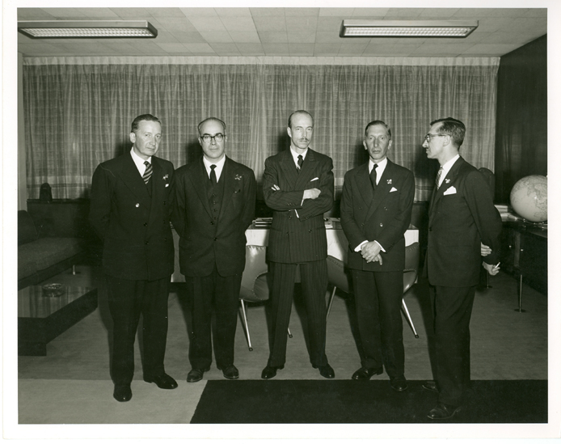

CUELLAR SERRANO GOMEZ STAFF

Paul Beer Archive

CSG is a colombian architectural, engineering and construction firm, funded in Bogotá, 1933, by engineer José Gómez Pinzón, the engineer - architect Gabriel Serrano Camargo, and the architect Camilo Cuellar. The first formed in the Universidad Nacional de Colombia, and the third, in London Architectural Association. In the 40’s become part of the staff the architect Gabriel Largacha, who had also been formed in the U.N Bogotá. CUELLAR SERRANO GÓMEZ played the lead rol in the modernization of Bogotá – the colombian capital – and the country in general. His extensive work includes projects spreading all around the country, as much architectural as engineering, leading the technological development in the local construction, either importing modern technology, or implementing new technologies tinged with local design, making CSG one of the cutting-edge Latinoamerican firm by mid-century XX.

In *Historia de la Arquitectura en Colombia* (1989) S. Arango considers CSG is “Colombian International Style’s highest point” as a result of the character of the era, in which the figure of the individual architect is replaced by large companies, as happens with SOM in the United States. However, we believe this is not so (remember that SOM was founded in 1936). More than a company, CSG resembles a medieval workshop, in which under the guidance of a master craftsman, a piece of work is done by a team; a hierarchical organization that allows to go forward a technically rigorous job, involving both architectural and engineering knowledge, achieving high quality work as a result of experimentation and master Serrano`s own empirical actitud.

Distinction between CSG and Serrano personal figure seems to be complex. Even though his workshop encircles his figure around, he was not interested in highlighting his own individuality. This fact among other things, makes Serrano be the master of the workshop, and not the architect-artist who seeks recognition. The large group of architects, engineers and technicians that were formed beside him would be responsible to disseminate the teachings of this particular modernity that CSG professed: traditional and avant-garde, conservative and experimental at the same time: a local modernity. Gabriel Serrano was also a great guild promoter, as both local as continental: he was the founding member, national president and lifelong partner of the Colombian Society of Architects, and similary, of the Colombian Society of Engineers; honorary member “College of Fellows” of The American Institute of Architects; member of The Brazilian Institute of architects, The Architect College of Chile, The Mexican Society of Architects, and The Venezuelan Society of Architects, among others; and finaly, president of Panamerican Association architects, between 1965 and 1968.

Serrano / CSG’s architecture is strongly influenced by Marcel Breuer work’s – a great artisan – as well as the modern brasilian architecture. Serrano traveled many times to Brasil, which deeply influenced his work: the formal correspondences between his work and paulista’s architecture and carioca’s architecture is evident.

His work is characterized by tectonic condition, in sense given by Semper, for its textile character; while in his early Works – through the 50s – the presence of the revetment is very important, in 60’s and 70’s works, the concrete take protagonic rol. In compositions terms, we can say that Serrano composed by *assemblage*, although less marked in golden age.

At the present, CUELLAR SERRANO GÓMEZ is a company whit corporative profile, but, whit the death of Gabriel Serrano in 1982, clearly this great workshop ended.

At the present, CUELLAR SERRANO GÓMEZ still exists as a company, but it is clear that with the death of Gabriel Serrano in 1982, this great workshop came to an end. (alternative)

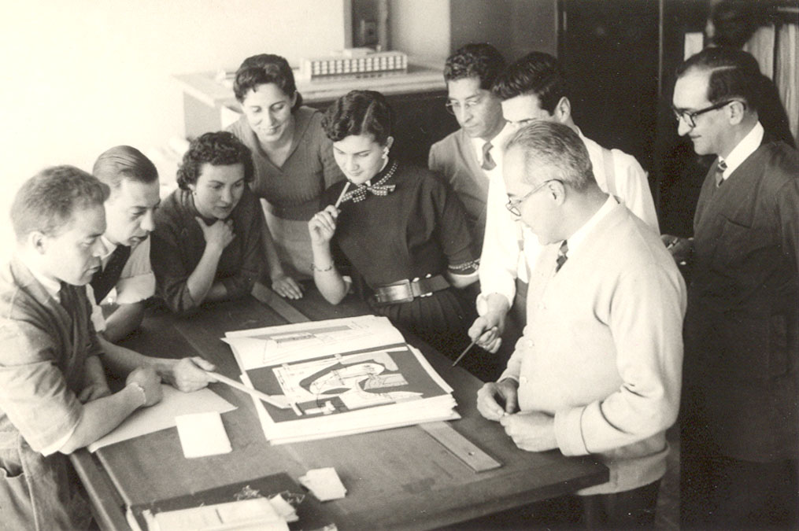

Serrano and his collaborators.

Hernando Camargo Archive

**List of works**

The early work of CSG was mainly housing assignments. By the end of 40’s the firm was entrust with the construction of several institutional buildings. CSG’s golden age began in the 50’s, with a long scale projects.

1941 Hospital San Carlos, Bogotá, COL

1947- 50 Club los lagartos, Bogotá, COL

1948 Edificio Camacho, Bogotá, COL

1951 Serrano House, Bogotá, COL

1956 Edificio Seguros Bolivar, Bogotá, COL

1957 Edificio Ecopetrol, Bogotá, COL

1954- 60 Aeropuerto El Dorado, Bogotá, COL

1957- 59 Sede Sociedad Colombiana de Ingenieros, Bogotá, COL

1962 Edificio Manuel Mejía, Bogotá, COL

1963- 64 Edificio Bachué, Bogotá, COL

**References and further reading**

Arango, S (1989) *Historia de la Arquitectura en Colombia*, Bogotá: Ed. Universidad Nacional de Colombia.

S.A. (1958) *Cuellar Serrano Gómez & Cia Ltda*, 1933 - 1958. Bogotá: Suramericana.

Saldarriaga, A (s.f) *Gabriel Serrano Camargo*, En: <http://www.banrepcultural.org/blaavirtual/biografias/serngabr.htm>

Serrano camargo, R (1983) *Semblanza de Gabriel Serrano Camargo.* Cuadernos Proa n° 2, Bogotá: Ediciones Proa.

Tellez, G (1988) *Cuellar Serrano Gómez – Arquitectura 1933 - 1983*, Bogotá: Ed. Escala.

Ulloa, M. (2007) *Serrano empírico*, Bogotá: Universidad Nacional de Colombia.

**Visual material:**

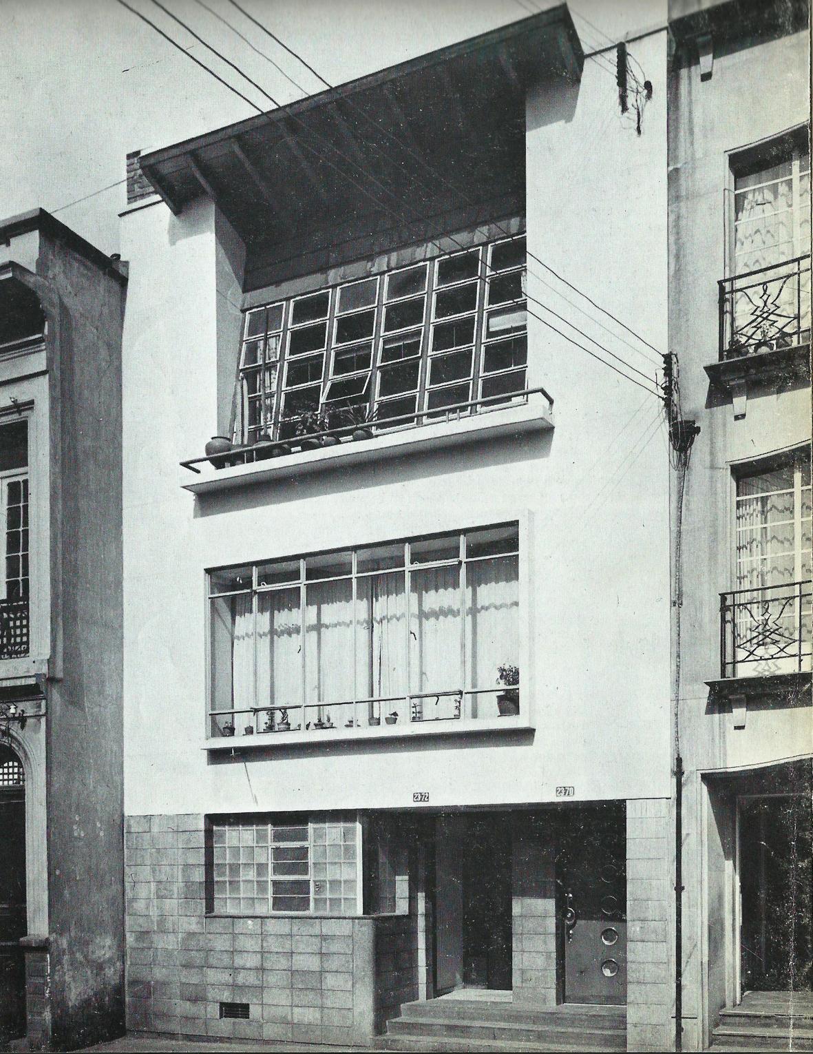

Serrano House, Bogotá,1939

Copyright: TELLEZ (1988)



Serrano House 2, Bogotá,1951

Copyright: TELLEZ (1988)

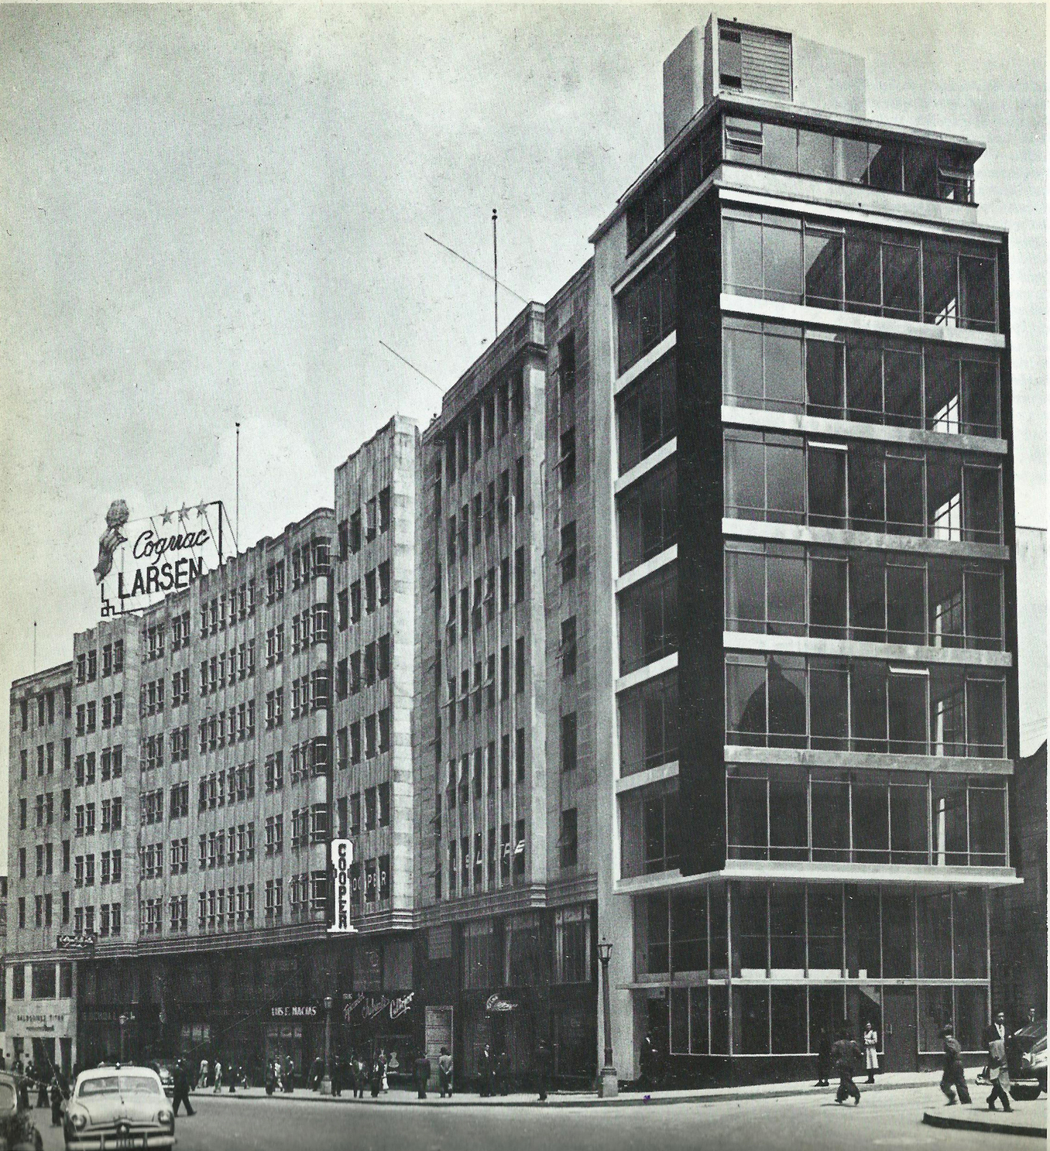

Camacho building, Bogotá,1949

Copyright: TELLEZ (1988)

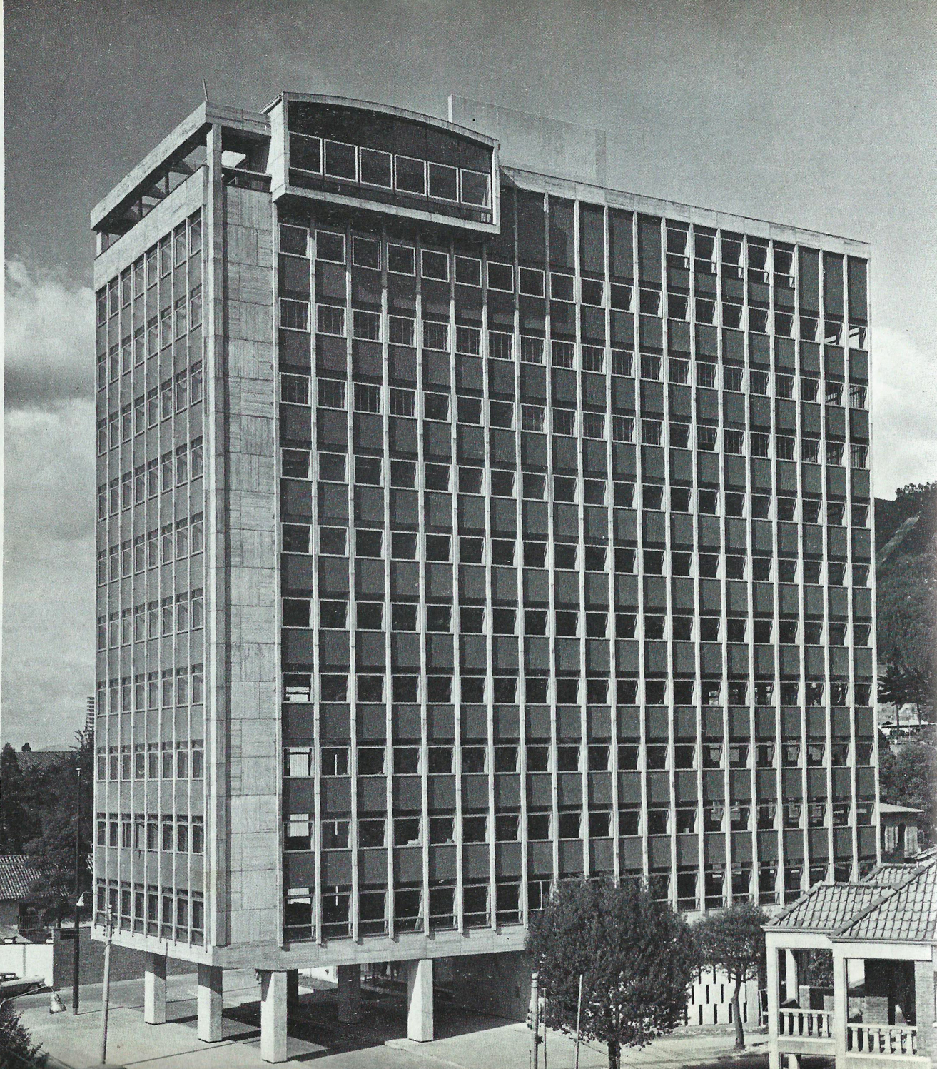

Ecopetrol Building, 1958

Copyright: TELLEZ (1988)

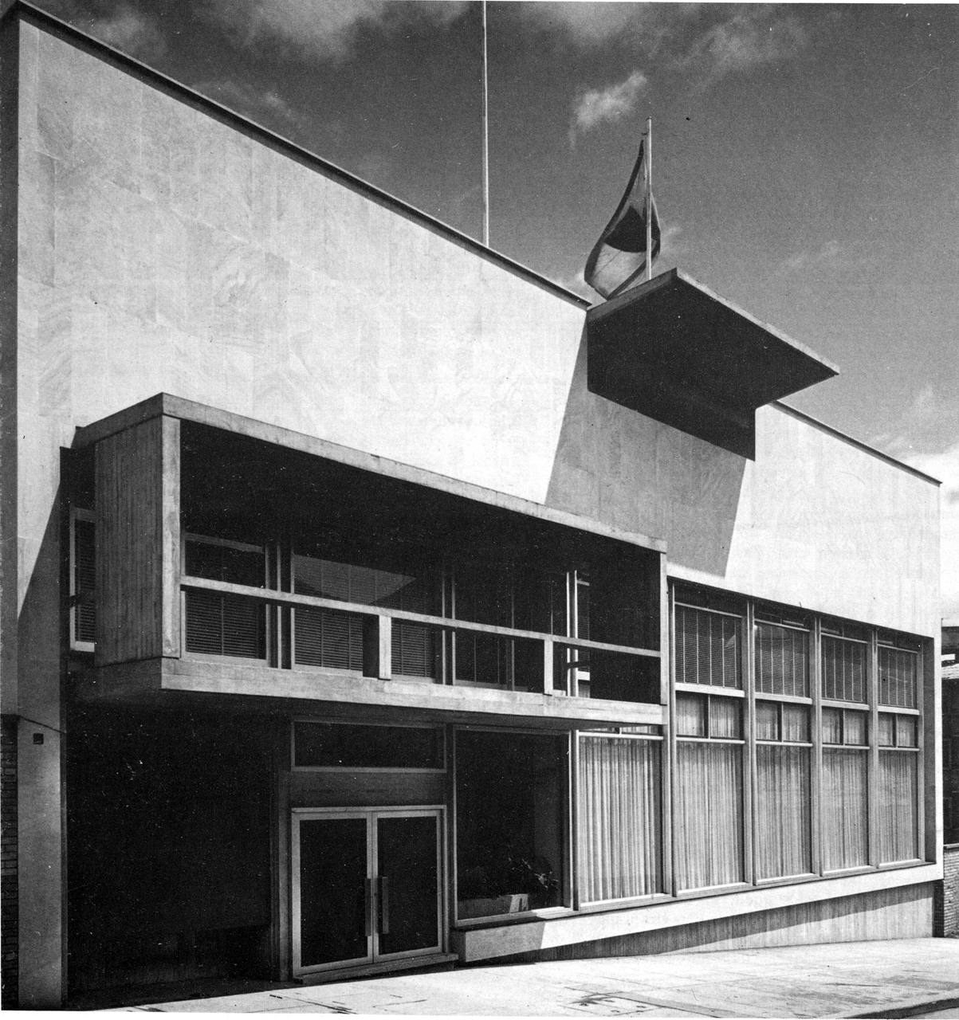

Sociedad Colombiana de Ingenieros Building, 1957 - 59

Copyright: TELLEZ (1988)

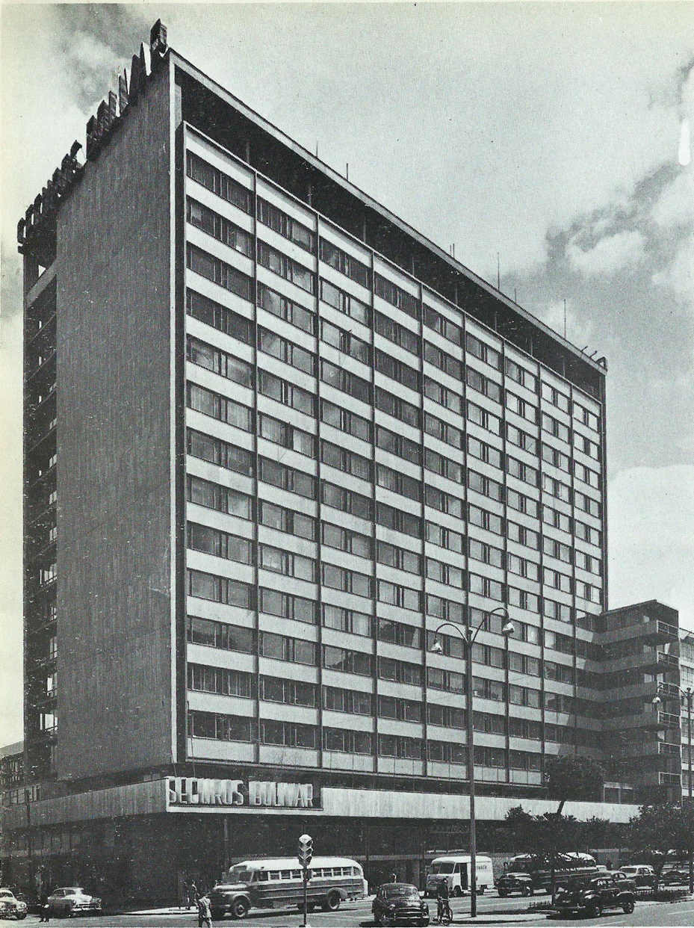

Bachué Building, Bogotá, 1963 - 64

Copyright: TELLEZ (1988)